43.40: particles. The absorbed dose is
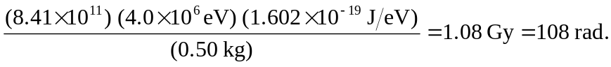
The equivalent dose is (20) (108 rad) = 2160 rem.

